STEP 2
Do not proceed with completing this task if your agency has not made the decision on whether or not to use Project Costing. If you have decided to use Project Costing, your agency must complete tasks PC001 (Project Setup) and PC002 (Source Type, Category, and SubCategory) before beginning the attached task.

TL002: TASK GROUP CREATION

In order to prepare for the system test phase, all agencies are asked to review the following task and submit the spreadsheet as noted in the instructions below no later than January 25, 2012.

TL002: Taskgroup Load – Due Jan. 25, 2012
If you are an agency who does not want their employees to report time per task profile, you still need to complete the task, setting up one task group, XXXNONTASK, where XXX is your 3 digit agency number. The task profile will be SOKNONTASK. See example below.

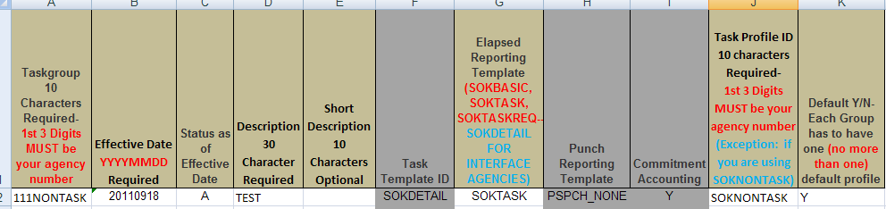

Overview

- Taskgroup is a group of task profiles. Each time reporter is assigned a taskgroup. The taskgroup attached to the Time Reporter data will default on the timesheet.
- The time reporter can choose from a list of task profiles within the taskgroup on the timesheet.
- Each agency will define specific taskgroups. A non-task reporting group (XXXNONTASK) will be set up for time reporters who are not required to report time per task data.

In this task we are asking for your agency’s Taskgroup definitions.

How do I determine my taskgroup values?

- Do you want the time reporters in your agency to report time per task profile?
  - If not, complete the task, setting up one group: XXXNONTASK, where XXX is your 3 digit agency number.
  - If yes, go to the next question
- Do you want all the time reporters in your agency to see all the taskgroups?
  - If yes, there is only one taskgroup required for your agency
  - If not, what are the logical groupings of task profiles?

Considerations:
- A generic taskgroup with a non-task task profile (no combo code or project information) will be created and assigned to the time reporters who do not need to report time to tasks. (XXXNONTASK)
- Taskgroup will default from Time Reporter Data and can be overwritten on the timesheet.

Initially, the taskgroups will be populated using the attached load. After the groups are loaded via the load, the agencies are responsible for maintaining the table online.

What will the Time and Labor Team do with this information?
- The Time and Labor Team will configure the Taskgroup table with the values provided by the agencies.
- This information will be used in the Time Reporter Data Conversion task.

Action Required
- Taskgroup: 10 character maximum. The Office of General Services requires that the first 3 digits of your Task Group be your 3 digit agency number. You can only use letters, numbers, and underscores as part of your taskgroup.
- Effective Date: YYYYMMDD. For this task, please use XXXXXX.
- Status as of Effective Date: A
- Description: 30 character maximum.
- Task Template ID: SOKDETAIL
- Elapsed Reporting Template: SOKBASIC, SOKTASK, SOKTASKREQ. If you are an interface agency, this value will be SOKDETAIL.
- Punch Reporting Template: PSPCH_NONE
- Commitment Accounting: Y
- Task Profile ID: 10 character maximum. This value will come from the values that you set up in TL004, Combo Code Task Profile. You cannot use a value here that was not included on TL004, unless you are using the SOKNONTASK for your task profile. The Office of General Services requires that the first 3 digits of your Task Profile be your 3 digit agency number. The exception to this is if you are using the XXXNONTASK as your taskgroup, the task profile will be SOKNONTASK.
- Default Y/N: Each taskgroup must have one (only one) default. This will be the funding that will be used if an employee does not specify which task profile that they want to use when they enter their time on the timesheet.

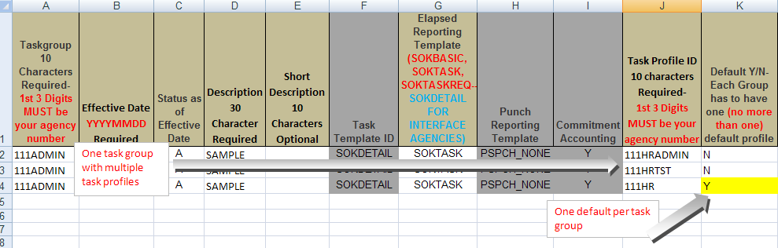

STEPS FOR SUBMISSION OF TL002:
- File Name is XXX.TL002 where xxx is the three digit agency code
- Please contact Heather DeBusk at Heather.DeBusk@da.ks.gov or via phone at 785.296.2434 for questions related to the Task Group file.
- Completed files must be submitted via e-mail no later than January 25, 2012 to Heather.DeBusk@da.ks.gov .

